CREATE A AIRFLOW ENVIRONMENTS IN AWS

STEP-1:
Login in to AWS Console In Service select a MWAA services.
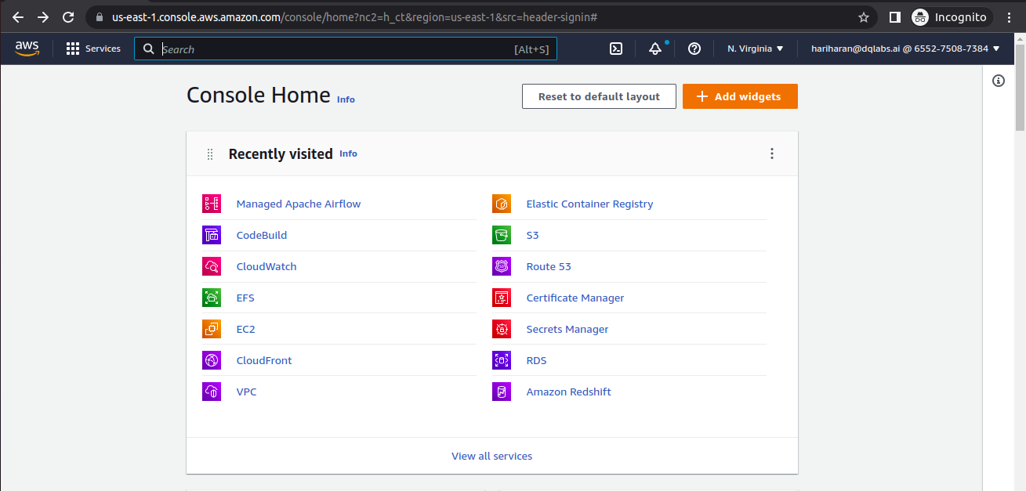

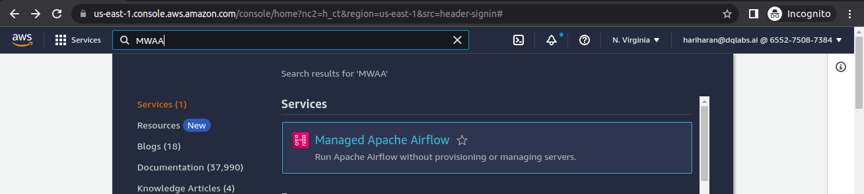
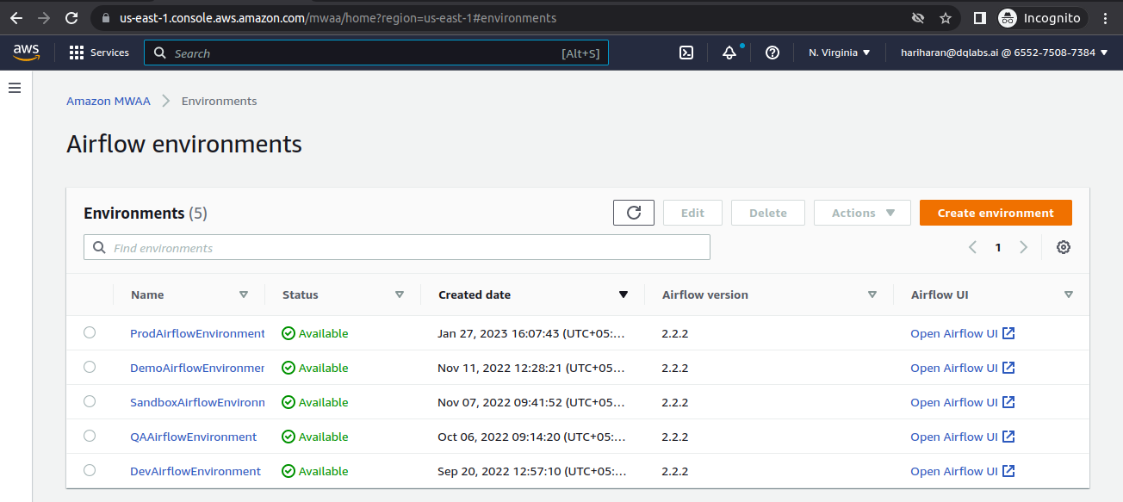

STEP-2:
Create a Environment and then give the name of the Environments And Browse the S3 Bucket-name where allocated to the airflow Environment .And select the Dags Folder and Plugins.Zip and requirements.txt from s3 bucket for the Airflow Environment.

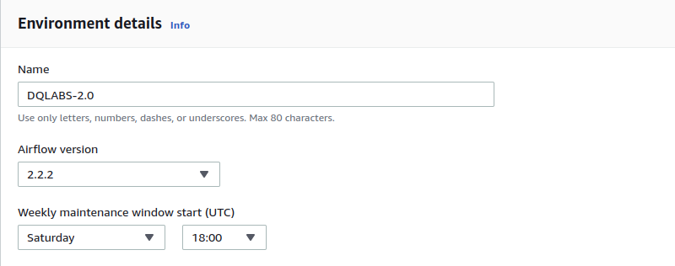
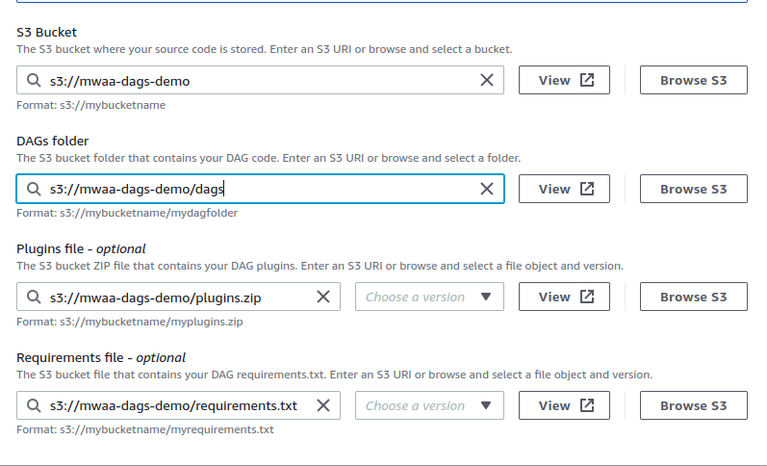

STEP-3:

Select the VPC for the Airfow and Subnet and Security group for the Environment.
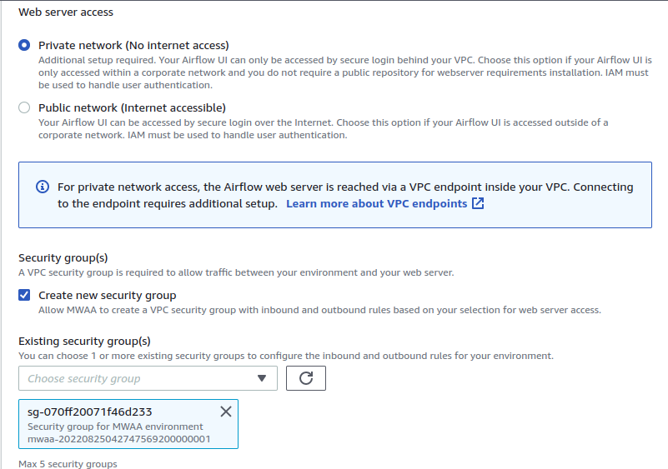
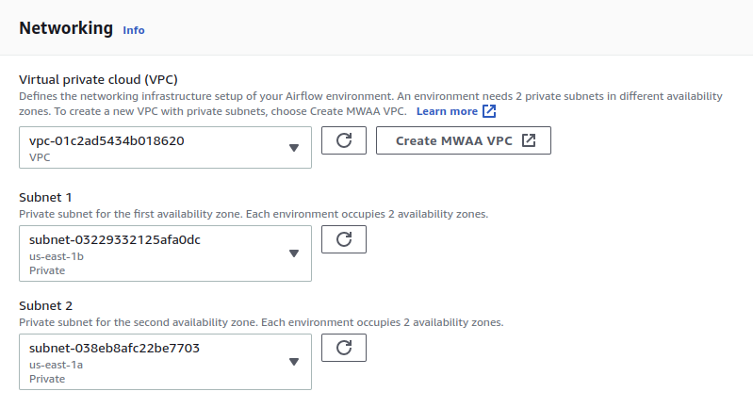

STEP-4:
Select the Environment Class and add the count for the Scheduler and Worker count.
And Enabled the monitoring logs and Tags and the IAM role permission for the Airflow Environment.

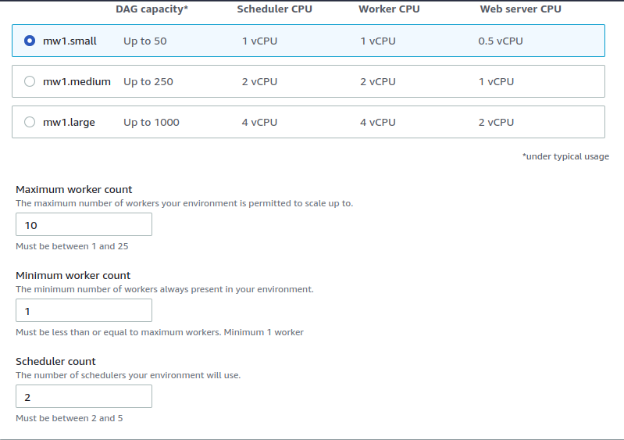
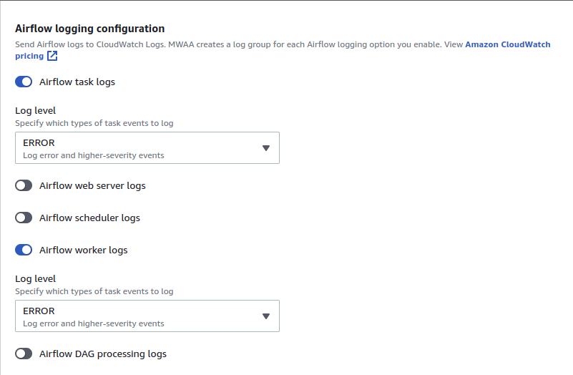

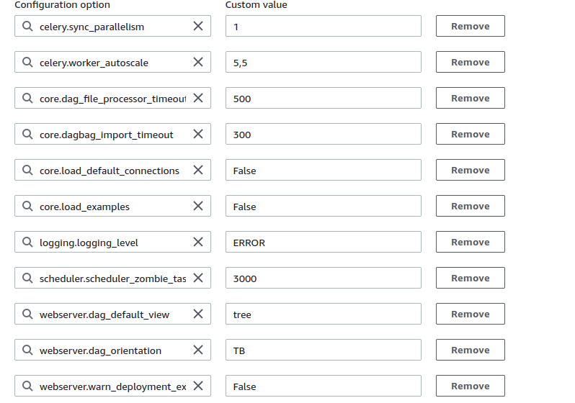
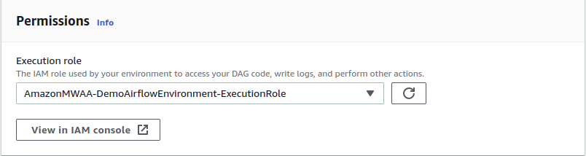

STEP-5:
Once Airflow Environments is Available just select open Airflow-UI use see the airflow webserver given below Images.

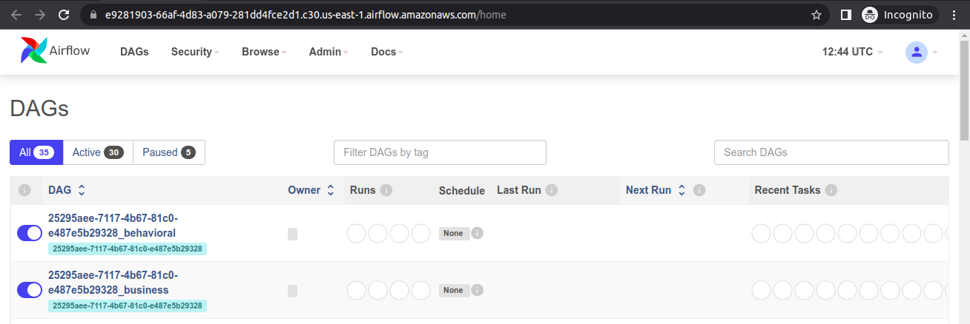

End Of the Document

